
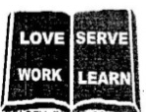
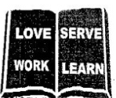
THE REAL SCHOOLS
LEARNER’S EMPOWERMENT ACTIVITY
P.4 SCIENCE TERM 1 2025
SANITATION

Golden Junior
School

Makindye Junior School

Victoria P/S
An excellent first grade and excellent character for every pupil

NAME………………………………………………. ………………………CLASS: …………………………………………… SCHOOL…………………………………………………………………………………………………………………………….

THEME: Human health
TOPIC: Personal hygiene
LEARNING OUT COME
To enable the learner, demonstrate good of keeping himself clean.
Competences
- Defines the meaning of personal hygiene
- Gives parts of the body that need be kept clean
- Gives the personal things that need to be kept clean
States the ways of keeping the body clean.
Phase 1
Key learning principle
personal hygiene Is the general cleanness of the bodies and things we use.
CONTENT
Personal hygiene
- Personal hygiene is the keeping of our bodies and the things we use clean or
- It is the general cleanliness of our bodies.
Parts of the body that needs proper cleaning:
fingers /finger nails
hair face teeth the skin
Things that should be kept clean.
♦Clothing ♦beddings ♦tooth brush ♦shoes
Ways of keeping our bodies clean How to keep our bodies clean
- Building regularly using safe water and soap.
- Cutting finger and toe nails short
- Washing face/eyes after sleep.
- Washing clothes regularly
- Brushing teeth every day
- Shaving overgrown hair.
- Washing beddings regularly
- Washing hands before eating or touching food.
- Ironing clothes and bedding. To kill vectors and germs.
Mini activity
- Give any two body parts that are always kept clean.
i)_____________________________________ii)________________________________
2. State any three ways of keeping our bodies clean
i)______________________ii)______________________iii)_______________________
3. State any five health practice a p.4 pupil can do maintain personal hygiene.
i)_____________________________________________________________________
ii)____________________________________________________________________
iii)____________________________________________________________________
iv) ___________________________________________________________________
v)_____________________________________________________________________
4. What is personal hygiene?
_______________________________________________________________________
5. Give the reason why teachers encourage every learner to groom the finger nails
_______________________________________________________________________
Items or things used in keeping our bodies clean
♦ Clean ♦ tooth brush ♦Earbuds
♦Bathing sponge ♦comb ♦ shavers
Towel ♦Nail cutter ♦ razor blade
♦Tooth paste ♦teeth pick ♦ soap
♦Dental floss
Importance of each of the item used for keeping personal hygiene/keeping our bodies clean.
 |  | IMPORTANCE
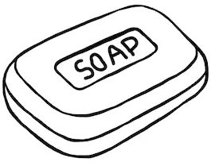  soap |  | Used when bathing to remove dirt  Used when washing hands to kill germs
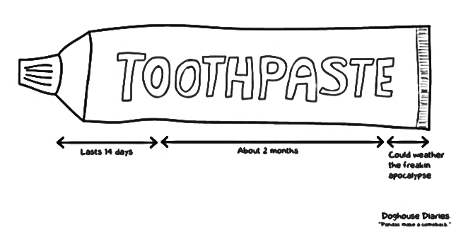  Tooth paste |  | Contains fluoride which makes teeth strong and prevent
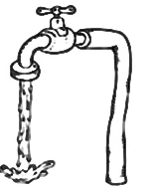  water |  | Used when washing to Hands to remove germs  Used when bathing to remove dirt and germs
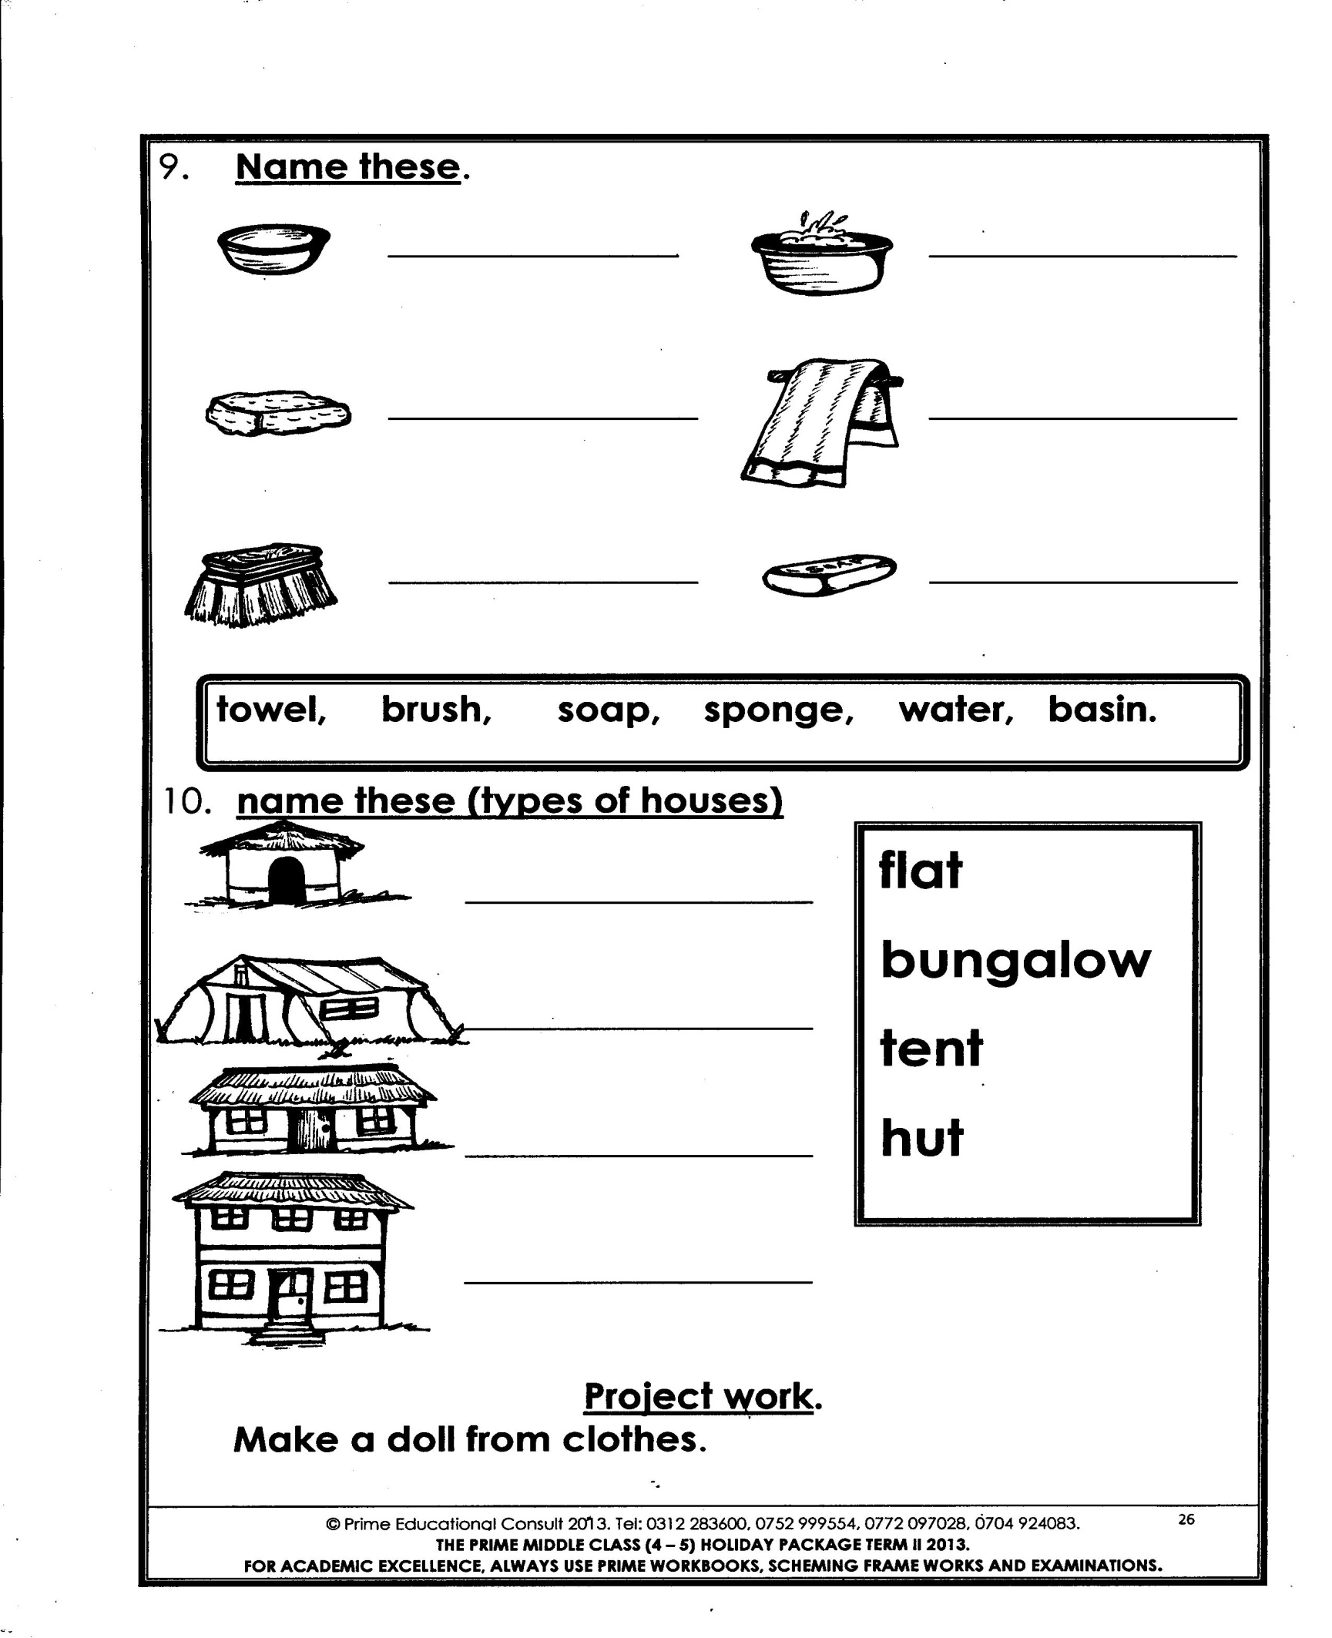 |  | Used for drying the body after bathing
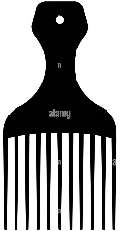 |  | Used for combing hair
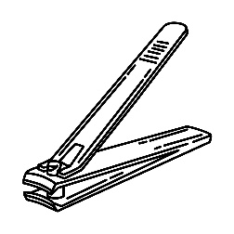  Nail cutter |  | Used for grooming finger nails
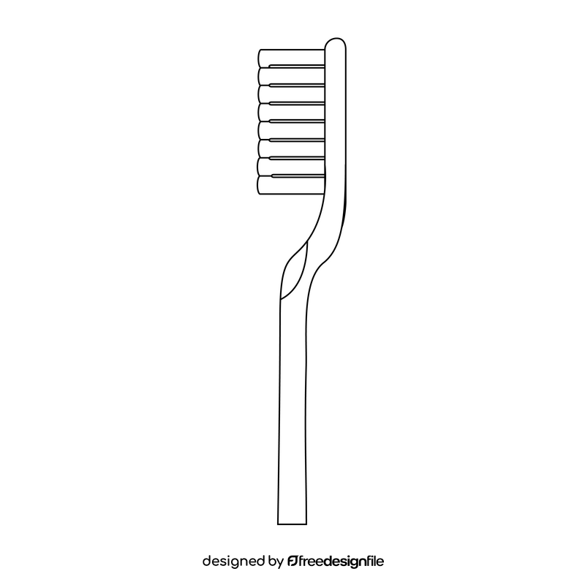  Tooth brush |  | Used for brushing teeth to remove remaining food particles from the mouth
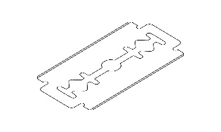  Razor blade |  | Used for cutting long finger nails
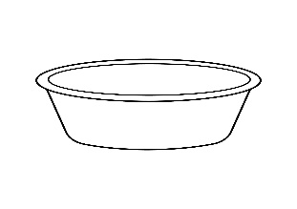  basin |  | Used for bathing and washing our clothes
Mini activity
- Write down any four examples of items used in maintaining personal hygiene.
i)___________________________________ii)__________________________________
iii)___________________________________ iv)_______________________________
- State the importance of each of the given items in (1) in our daily life.
i)________________________________________________________________________
ii)_______________________________________________________________________
iii)______________________________________________________________________
iv)_______________________________________________________________________
- Draw the item used for removing the remaining food particles in the mouth.

- State any one reason why we advised to trim our hair
_________________________________________________________________________

MEGA ACTIVITY
- Give the item used for removing wax in the ear.
____________________________________________________________________
- Give the reason why we wash our hand after visiting the toilet.
_____________________________________________________________________
- State the importance of using tooth paste when brushing teeth.
______________________________________________________________________
- Give the reason for washing hands with soap.
_____________________________________________________________________
- State any one danger of sharing razor blade.
______________________________________________________________________
Importance of keeping our bodies clean
♦ It controls the spread of germs ♦ It helps one to be healthy
♦ It prevents skin diseases ♦ prevents breeding of diseases vectors
♦ It prevents bad body smell ♦ It removes sweat and dirt.
♦It prevents teeth diseases
♦Removes dirt from the body
♦ We clean our bodies to be smart and healthy
Dangers of poor personal hygiene
- It can lead to the spread of skin diseases.
- It can lead to the teeth decay
- Diarrhoea diseases can spread easily.
- Jiggers, mites, ticks and lice can breed and affect the body
- Accidental injuries from long finger nails to self or others
- It can lead to bad body smell.
- There is easy spread of germs
Diseases brought by poor personal hygiene.
Tooth decay__ bacteria scabies__ itch mites
Dysentery____ amoeba Diarrhoea___ bacteria
Ringworm infection___ fungus Trachoma ___chlamydia
Athlete’s foot___ _fungus Impetigo___ bacteria
How to keep things/ items at home clean.
Utensils
▪Washing them after use. ▪Drying them on a plate stand
Reasons for cleaning utensils
- To prevent houseflies from landing on them.
- To prevent them from contaminating food
- To prepare them for the next use
MINI ACTIVITY
- State any two diseases caused due to poor personal hygiene.
i)__________________________________ii)__________________________________
2. State any two importance of keeping our bodies clean.
_______________________________________________________________________
_______________________________________________________________________
3 State two ways of keeping utensils clean.
i)_____________________________________ii) _______________________________
4. Mention any two importance of cleaning utensils
________________________________________________________________________
________________________________________________________________________
Keeping beddings and clothing clean
Beddings include: bedsheets, a blanket, bed cover, mattress and pillow
Clothing means what is worn on our body like shirts, under wears, socks, dresses, shorts, blouses, scarves etc
Ways of cleaning beddings and clothing
Washing them using water and soap/ detergents
Ironing them when washed
A mattress and blanket should be put under sunshine after a few weeks to kill parasites and germs.
Keeping them in clean safe places if not in use.
Laying the bed every morning.
Things used to clean beddings and clothing
▪Soap /Detergents ▪washing brushes ▪ water flat iron/ ▪iron box ▪suit cases
Importance of keeping beddings and clothing clean
♦To remove dirt ♦To keep away bad smell
♦To remove germs ♦To look smart
♦It prevents skin diseases ♦To prevent diseases vectors from breeding
♦Ironing remove wrinkles and kills eggs of parasites from clothing and beddings
Vectors that breed dirty beddings and clothes
Lice fleas mites_ bedbugs
A clean and neat bedroom
Bedroom
Ways of keeping our rooms clean
- Sweeping the floor
- Scrubbing the floor
- Mopping the floor
- Removing cobwebs
Reasons for cleaning our bedrooms
- To prevent breeding of diseases vectors
- To prevent bad smell in the bedroom
- To remove dirt
- To keep it neat and clean

MINI ACTIVITY
- State any two vectors that spread through poor personal hygiene
i)____________________________________ii)______________________________
2. Mention any two importance of keeping the beddings clean
_____________________________________________________________________
_____________________________________________________________________
3. Give the reason why beddings should be put under sunshine.
_____________________________________________________________________
4. Write down any two things used for cleaning beddings.
i)_________________________________ii)_________________________________
5. Identify any one health practice done to kill germs in beddings a part from them under sunshine
______________________________________________________________________
MEGA ACTIVITY
- Name the vector that spreads scabies to people.
______________________________________________________________________
2. State one way how the practice of ironing helps to maintain personal hygiene.
_______________________________________________________________________
3. State the danger of bitting finger nails.
_______________________________________________________________________
4. Give the importance of bristles in tooth brush during brushing of teeth.
_______________________________________________________________________
5. State the use of bathing sponge when bathing.
_______________________________________________________________________
6. State the bad health practice that results to tooth decay.
_______________________________________________________________________
7. State any one way of keeping our beddings clean.
_______________________________________________________________________
8. Identify any one health practice that makes school children smell good.
________________________________________________________________________
9. Mention any one fungal disease caused by poor hygiene.
________________________________________________________________________
10. Give any one detergent used when washing beddings.
_______________________________________________________________________
11. a) In space below draw and name any three items used for keeping personal hygiene
b) State any one way caring for the towel.
____________________________________________________________________
12. State any two ways of cleaning the
a) Bedroom ___________________________________________________________
b) Utensil _____________________________________________________________
13. a) State one importance of sun maintaining personal hygiene.
______________________________________________________________________
. b) Name the item used when ironing clothes and beddings.
______________________________________________________________________
c) Mention any two importance of keeping beddings clean.
_____________________________________________________________________
_____________________________________________________________________

